Daily Assignment:
Hands-On Lab 9:
Build ETL Pipeline Scenario Load customer data from:

CSV → Staging Table → DWH Table

Steps:

1. Load CSV
2. Clean data
3. Load to warehouse

1. Load CSV (Extract)
- Extract: The first step is to load or extract the customer data from a CSV file. This involves reading the data from the CSV file into a staging area, where it is temporarily stored before any transformations or clean-up.

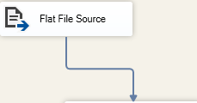

2. Clean data

Common Transformations:
- Remove Duplicates: Use a Sort Transformation to remove duplicate records (e.g., based on customer_id).
- Standardize Data: For example, format the phone numbers or handle null values.
- Handling Missing Values: Use Derived Column Transformation to replace or handle nulls.
- Convert Data Types: Ensure all columns in the Staging Table have the correct data types.
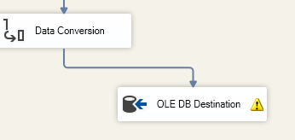

3. Load to warehouse
Now that the data is cleaned, you can load it into the Data Warehouse (DWH) table.

